Paper Prototype & Digital Prototype
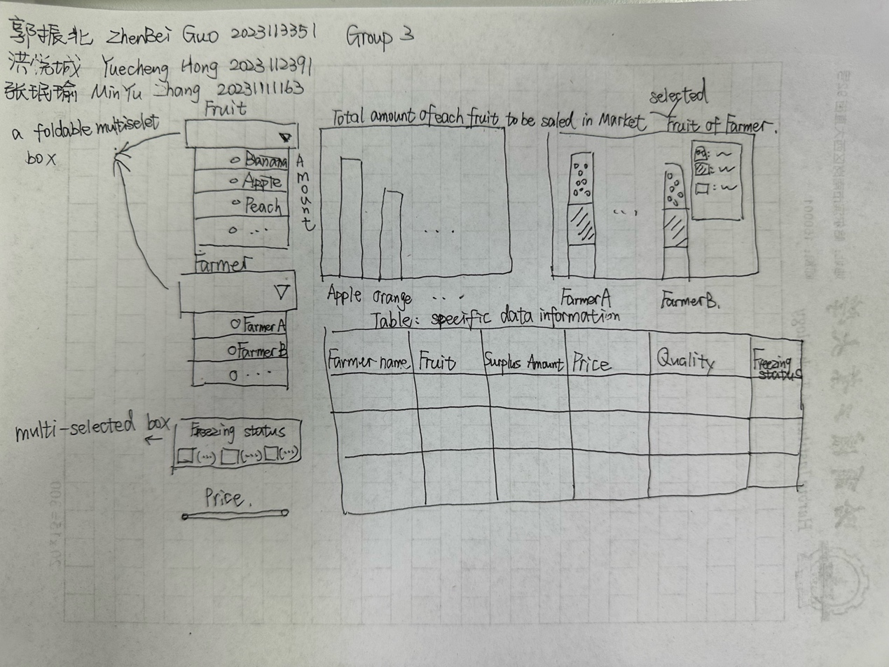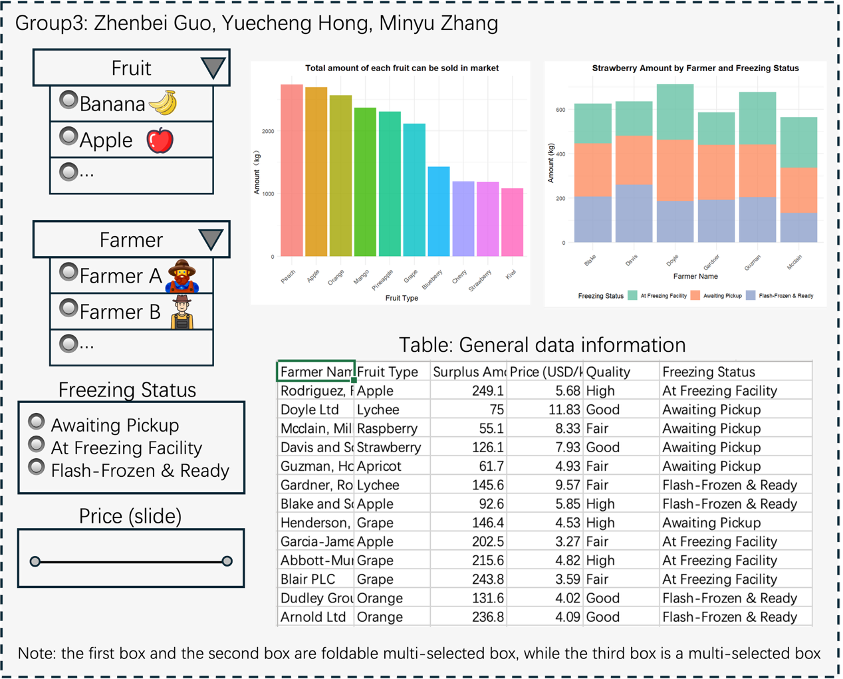
shiny app for prototype
https://mikehong.shinyapps.io/in_class_act/

Deployment:
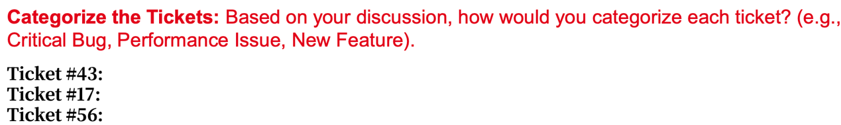
Ticket #43: Critical Bug
Ticket #17: Performance Issue
Ticket #56: New Feature
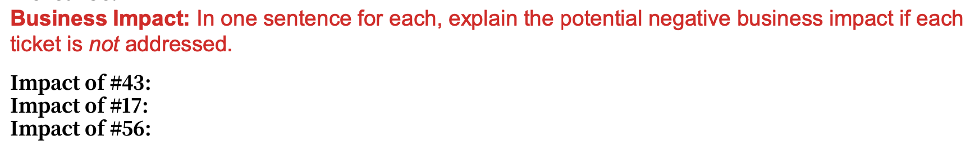
1: Ticket #43, 2: Ticket #17, 3: Ticket #56
#43: If this issue is not resolved, farmers will lose trust in the application due to data errors, leading to low operational efficiency and even business loss.
#17: If this issue is not resolved, users will be unable to effectively plan their work during peak hours, leading to lost productivity and user dissatisfaction.
#56: If this issue is not resolved, the marketing team will be unable to obtain the data needed for reporting, which could affect their decision-making and reporting processes.

Reason: Data accuracy is the cornerstone of application credibility. If core data is incorrect, the value of the application will be completely undermined, and even if other problems are solved, they will be meaningless.

Ticket #43
The goal is to simplify operations for farmers while ensuring real-time data exchange between Google Sheets and the enterprise app using googlesheets4. A simple tool will be created for farmers, featuring a dropdown menu for fruit types, a weight input box, and a submit button, along with voice input support. Farmers can give voice commands like "Blueberry minus 40," which will be automatically converted into the appropriate inputs. Once the data is submitted, the system will use googlesheets4 to update a shared Google Sheet in real time. The enterprise app will regularly fetch the latest data from the sheet using reactivePoll, calculate the current inventory, and update key details like "excess quantity" to ensure the data remains accurate and aligned with what farmers submit.
The Google Sheet will be structured with fields like fruit type, original stock, change amount, current stock (calculated automatically as original stock plus change amount using a formula), update time, and farmer ID. On the farmer's side, the process starts with receiving the fruit type and weight change entered by the farmer. The system then validates the data, making sure the inventory won’t go negative after the change. It reads the original stock for the fruit from the sheet using googlesheets4, calculates the new stock, and updates the sheet with the new information. On the enterprise side, reactivePoll triggers a data refresh every 15 seconds. The system reads the latest data from the sheet using googlesheets4, extracts the fruit types and current stock, and displays this information for the enterprise to monitor and use.
First, pre-testing and permission setup will be done. Ten farmers will test the input tool, including the voice function, and the options will be improved based on feedback, such as organizing the fruit dropdown by local planting frequency. Sheet permissions will be adjusted so farmers can only edit their own rows, while the enterprise side will have read-only access to prevent accidental changes. Next, data migration and parallel operation will take place. Existing inventory data will be imported into the sheet using googlesheets4's bulk writing feature. The old and new systems will run together for three days after launch, and the old system will be turned off once the data matches. Finally, deployment will be scheduled for Saturday morning, a low-activity time for farmers. Graphic guides, including steps for using voice input, will be shared, and technicians will visit elderly farmers to provide training, ensuring everyone can use the system smoothly.
One issue is multi-user editing conflicts. When multiple farmers update data for the same fruit at the same time, it can cause confusion in the sheet. To address this, the "conflict alert" function in Google Sheets will be enabled, and a "Updating, please wait" lock message will be added on the farmer’s side to ensure only one person can edit the same fruit’s data at a time. Another issue is unstable networks. Poor signals in remote areas may lead to data submission failures. To solve this, an offline cache will be added on the farmer’s side to temporarily store input data. The system will automatically retry submission when the network is restored and show a "Successfully updated" message after synchronization, so farmers know their operation was completed.
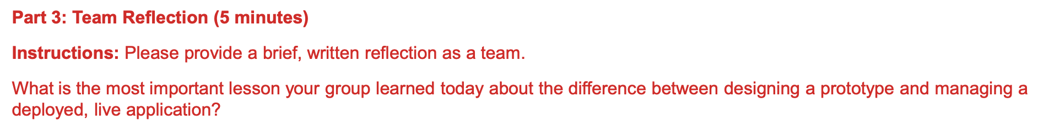
We gained a lot from this process. First, creating a prototype was essential as it directly guided the direction of our development. Throughout this stage, we held multiple group discussions, made numerous drafts, and continuously refined our design until we finalized the prototype. Second, during the process of implementing the prototype with code, we engaged in deeper thinking and decision-making. These brainstorming sessions helped us reassess the logic and feasibility of our prototype, leading to further optimization and a better presentation of the final dashboard. During the deployment phase, new issues or requirements often emerged during user handover. The most important skill here was the ability to conduct timely risk assessments, quickly prioritize the order of problem-solving, and work as a team to find effective solutions, which ultimately allowed us to further improve the product.

Web of Science analysis (EDA+clustering)
We chose to analyze the publication trends of humanoid robotic as our target technology field to analyze.
https://www.webofscience.com/wos/woscc/summary/d99e6ade-0050-4cb1-977e-68bde4f080e6-01872a38cf/relevance/1
Overall, the bar chart indicates that the number of publications in humanoid robot has been increasing over time, especially the recent years, reflecting its growing attention within the academic world.
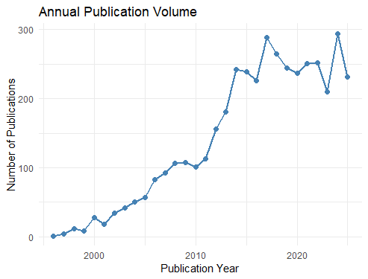
Additionally, the TreeMap chart could reveal the fields that most related and co-emerge with humanoid robot research, which are CS, AI, Electrical & Electronic and automation etc.. We could significantly notice that AI has been take control within this area instead of traditionally the EE and system control area.
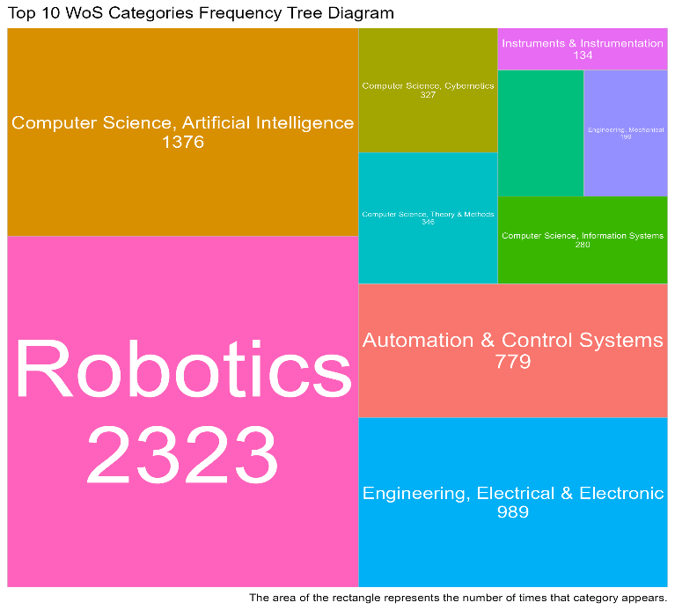
It’s not surprising that the majority of publications are from the United States. However, it’s a surprise to see that PRC don’t take much space within humanoid robot area, and the Switzerland & Netherlands has relatively control here. This highlight the importance of academic cumulation because of they are traditional industrial countries, aware us of there is a great gap to be bridged.
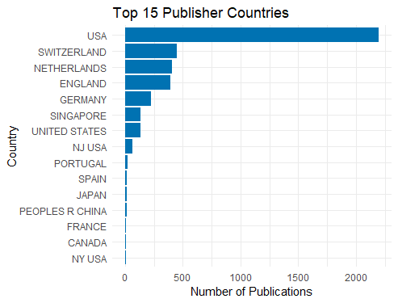
After researching and visualizing the citation counts of scholars in this research field and focusing on the top 10 most-cited scholars, we found that Scholar Metta, Giorgio has a distinct advantage in citation count, approaching 2500, which far exceeds other scholars. The citation counts of the remaining scholars gradually decrease from approximately 1900 to around 800. It can be predicted that Metta, Giorgio should be a relatively prolific and outstanding author in this research field.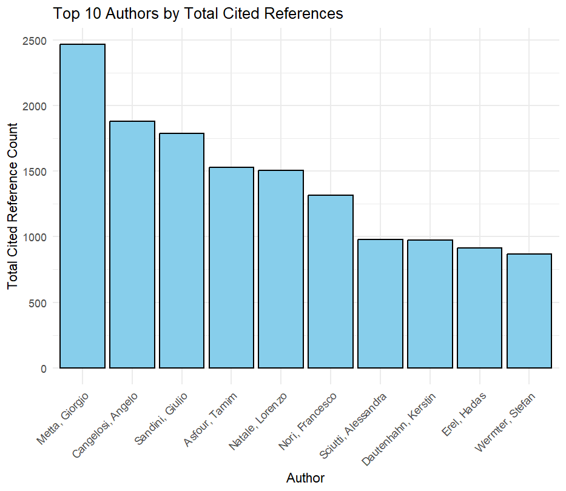
In terms of document types, this pie chart shows the distribution of document types in this research field. Among them, Proceedings Paper accounts for 56%, Article for 40%, Review for 3%, and Other for 1%. It can be seen that the research outputs in this field are mainly presented in the form of conference papers (Proceedings Paper) and journal papers (Article), with the two accounting for more than 90% in total, while Review and other types of literature account for extremely low proportions.
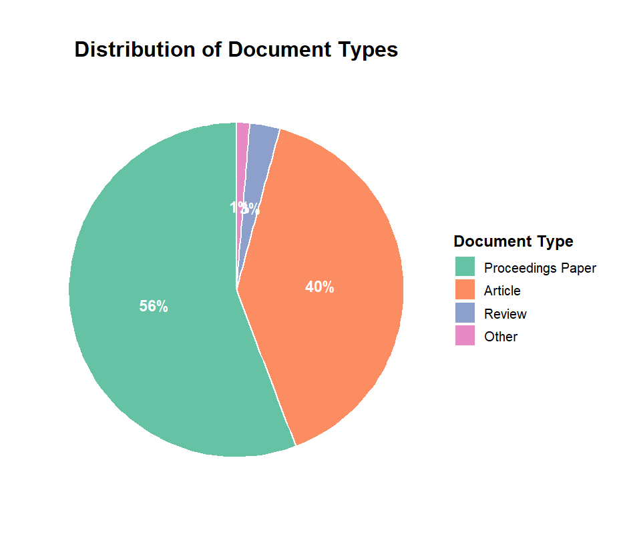
This word cloud clearly shows the distribution of core journals in this field. Among them, journals such as “IEEE ROBOT AUTOM LET” and “INT J HUM ROBOT” have prominent font sizes and are the core venues for publishing research outputs in this field. Meanwhile, journals like “ADV ROBOTICS” and “INT J SOC ROBOT” also occupy important positions, reflecting that the research outputs in this field are highly concentrated in journals of subfields such as autonomous robots and human-robot interaction. These core journals together form the key carriers for academic exchange and output dissemination in this field.
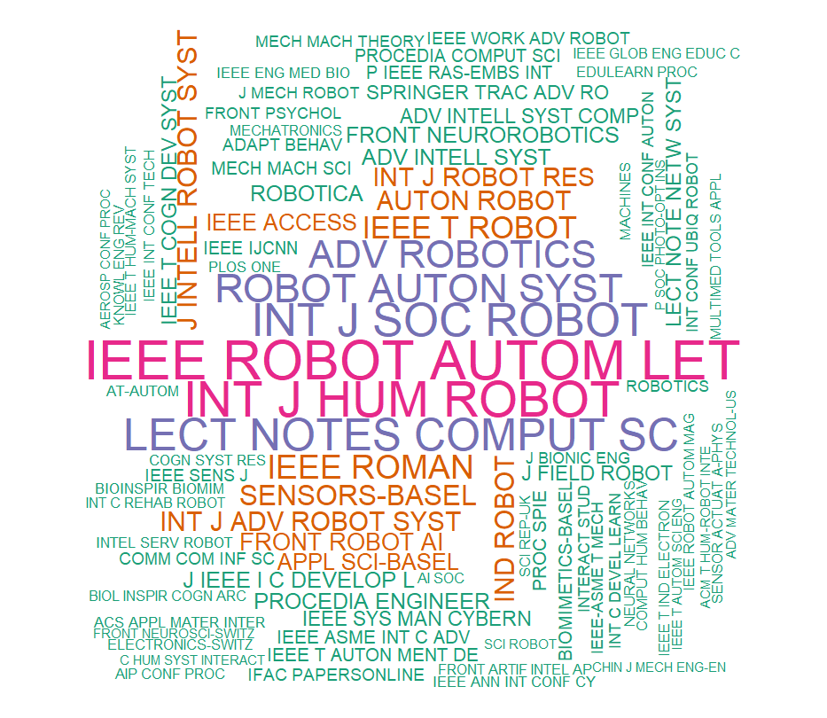
In the Academic Landscape Modeling section, we applied Latent Dirichlet Allocation (LDA) to perform topic modeling on the article titles and abstracts of each paper. We categorized these papers into ten topics and conducted several visualization analyses.

Q: What clusters emerge in robotics research?
Based on the analysis of keywords in each cluster, we identified ten LDA topics that can be grouped into the following primary research clusters: Topic 3 and Topic 6 focus on human-robot interaction and social robotics; Topic 4 and Topic 8 concentrate on robotic hardware design and mechanical structures; Topic 1, Topic 5, and Topic 9 are dedicated to robot control and motion planning; Topic 7 emphasizes artificial intelligence and machine learning; and Topic 2 and Topic 10 pertain to general robotics research and reviews. It is evident that distinct and well-defined research pathways exist within this dataset.
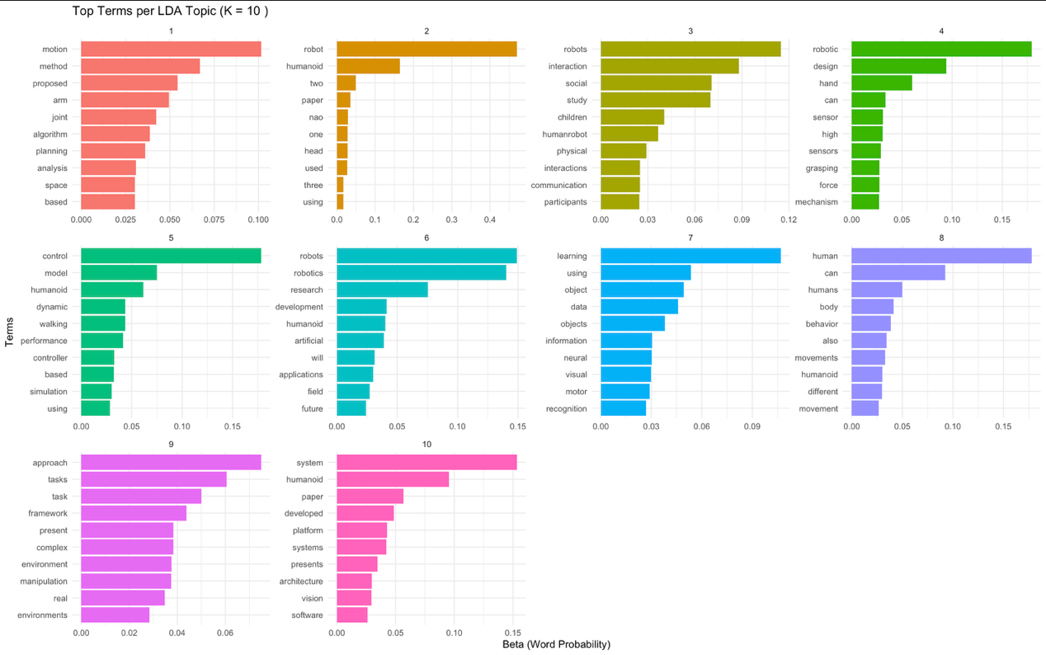
Q: Are there distinct research approaches or focus areas?
The grouping of LDA topics clearly illustrates the presence of distinct research approaches in the field of robotics. These include application-oriented studies on human-robot interaction (Topic 3, Topic 6) and hardware design (Topic 4, Topic 8), as well as foundational studies in control systems and motion planning (Topic 1, Topic 5, Topic 9). Additionally, there is a strong emphasis on artificial intelligence (Topic 7) and broader theoretical or review-based studies (Topic 2, Topic 10). These clusters reflect the diversity of the field, ranging from theoretical advancements to applied innovations.

Q: Which research characteristics correlate with higher impact?
Our analysis of average citation counts for each cluster reveals that Topic 6 and Topic 3 are high-impact areas. This indicates that research exploring future applications of robotics, proposing new paradigms or systems with broad potential, and addressing how robots can safely, effectively, and naturally interact with humans, especially children, tends to garner significant academic attention and citations. Topics 7 and 4 are medium-impact areas, receiving substantial but relatively lower attention. The remaining clusters have lower impact, as they often focus on foundational or theoretical research, which tends to have lower independent citation rates compared to application-driven outcomes. In robotics, the most impactful studies are not purely technical but those that define future directions, address human-robot interaction challenges, or demonstrate novel application potentials. "Application-oriented" and "human-robot interaction" research are the golden rules for achieving high impact.
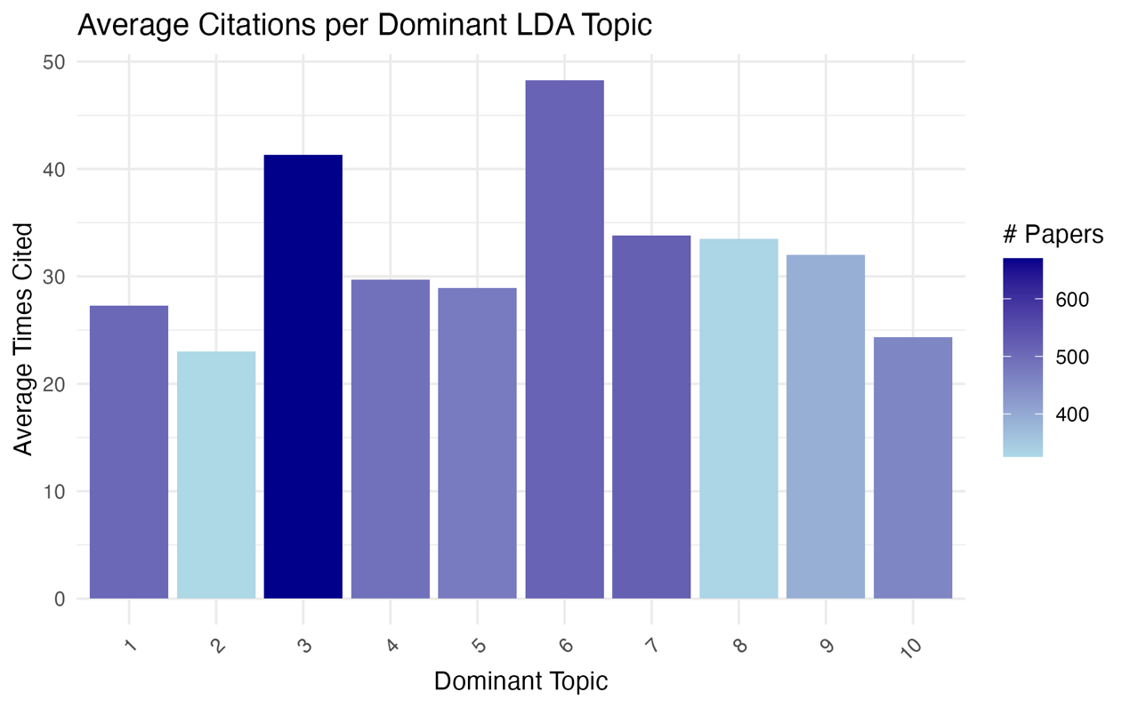
Q: How could these insights guide future business directions?
Businesses should prioritize investment in high-impact areas such as human-robot interaction (Topic 3) and robotics application development (Topic 6). While foundational technologies may not have high citation rates, they are essential for building successful products. Companies should allocate resources to artificial intelligence and machine learning (Topic 7) as well as hardware design (Topic 4) to ensure their products possess robust perception, decision-making, and physical execution capabilities. It is advisable to avoid focusing solely on theoretical or generalized research (Topic 2, Topic 10). Instead, these should be transformed into tangible, verifiable product prototypes or application scenarios.

Q: What limitations should businesses be aware of?
LDA models have inherent limitations, and citation counts are not the sole measure of impact. The analysis is based solely on data from the Web of Science (WOS) database, which may introduce biases or overlook interdisciplinary contributions.

